
LOYOLA COLLEGE (AUTONOMOUS), CHENNAI – 600 034
U.G. DEGREE EXAMINATION – GENERAL ENGLISH
SECOND SEMESTER – APRIL 2011

EL 2067 / 2070 - INTRODUCTION TO TECHNICAL TRANSLATION

Date : 02-04-2011 Dept. No. Max. : 100 Marks
Time : 9:00 - 12:00

SECTION-A

I Answer any FIVE of the following in about 75 words each: (5 x 4 = 20)

1. What are the different types of translation?
2. Identify the problems involved in translating advertisements.
3. Bring out the differences between literary translation and technical translation.
4. Explain the following terms a) transliteration b) transcription
5. How do you enhance the quality of technical translation?
6. What is equivalence? Give examples.
7. Explain the problems in lexical transfer.
8. Distinguish Formal correspondence and Dynamic equivalence.

II Answer any THREE in about 250 words each: (3 x 10 = 30)

9. What are the responsibilities of a translator?
10. Identify the characteristics of technical translation.
11. Do you consider translation an art, a science or a craft? Discuss.
12. Write an essay on the translation of Science texts.
13. What are the benefits of technical translation?

SECTION –B
III Translate the following into the target language ( Tamil) (10 x 1 = 10)

- Measurement
- Judge
- Proposal
- Treasury
- Hostel
- Governor
- Gazette
- Board
- Council
- Share market

IV Translate the following newspaper headlines into Tamil (5 x 2 = 10)

- India takes on Bangladesh in World Cup opener.
- Srilanka frees Indian fishermen.

High Court orders Election Commission to send school teachers for election duty after exams end.
- All Indians to be back home from Libya by Friday.
- Tata Motors launches new Indica.

V Translate the following science text into Tamil (10 marks)

Modern cell phones are capable of much more than just sending and receiving phone calls. Mobile phones used in today’s world allow users to send and receive text messages, emails, photos and video as well as access the Internet, play games, listen to music and more.
The cell phone has become an important communication tool that is used by people all over the world to keep in contact with each other at any time. Although they started off as quite bulky devices they are now very sleek, small and portable, comfortably fitting in a users pocket and surviving for hours on end thanks to a rechargeable battery.
Cell phone designs are constantly evolving to incorporate the new needs and desires of users. Some of these new functions include space for memory cards, flip screens, cameras, touch screens etc.

VI Translate the following news item into English (10 marks)
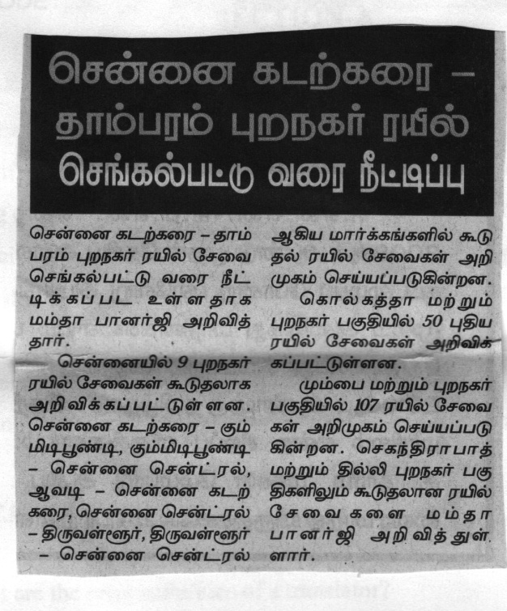
VII Translate the following advertisement into English (10 marks)




